Configuring VLANs and Trunking - Worksheet

This is a very busy week, but it is necessary that you get a working understanding of some advanced switching concepts – especially VLANs. The goal is for you to spend no more than an hour on this project. If you pay attention and follow instructions, this will happen. Here are some points to note:
- All resources required for this project have been provided in your Configuring_VLANs_and_Trunking_Student_Project.pkt file. All PCs have been added and addressed on the 192.168.1.0/24 network. Crossover cables have been connected to the gi interfaces between the switches.
- Spanning Tree Protocol (STP) has been disabled on the switches. This is rarely, if ever, a good idea, but it is necessary for this project. You will enable it during the project.
- The switches have been configured with a VTP domain name (Provo). The Team 1 switch is also in VTP Server mode. No passwords have been configured.
- Be aware that one of the first things we demonstrate may cause your computer to become unstable. It will certainly affect Packet Tracer. Please save any open files of any importance before continuing.
- Try to use range commands as much as possible. It will save time and improve accuracy.

Here is the information you will need for the project:

IPv4 Assignments:
PC Name |  | Initial Configuration | VLAN Name | VLAN Configuration
Sales 1 |  | 192.168.1.11 | Sales | 192.168.1.10
Marketing 1 |  | 192.168.1.12 | Marketing | 192.168.2.10
Admin 1 |  | 192.168.1.13 | Admin | 192.168.3.10
Sales 2 |  | 192.168.1.21 | Sales | 192.168.1.20
Marketing 2 |  | 192.168.1.22 | Marketing | 192.168.2.20
Admin 2 |  | 192.168.1.23 | Admin | 192.168.3.20
Sales 3 |  | 192.168.1.31 | Sales | 192.168.1.30
Marketing 3 |  | 192.168.1.32 | Marketing | 192.168.2.30
Admin 3 |  | 192.168.1.33 | Admin | 192.168.3.30

VLAN Information:
VLAN Information | Port Assignments
10 Sales | 1 – 4
20 Marketing | 5 - 8
30 Admin | 9 – 12

VLAN Configuration Commands
The following table shows common VLAN configuration commands:
Command | Description
switch(config)#vlan [1-1005] | Defines a VLAN.
switch(config-vlan)#name [unique_name] | Gives the VLAN a name.  Naming the VLAN is optional. VLAN names must be unique.
switch(config)#no vlan [1-1005] | Deletes a VLAN.  When you delete a VLAN, all ports assigned to the VLAN remain associated with the deleted VLAN and are, therefore, inactive. After a VLAN is deleted, you must reassign the ports to a VLAN.
switch(config-if)#switchport access vlan [1-1005] | Assigns ports to the VLAN.  If you assign a port to a VLAN that does not exist, the VLAN is created automatically.
switch#show vlan  switch#show vlan brief | Shows a list of VLANs on the system.
switch#show vlan id [1-1005] | Shows information for a specific VLAN.

VTP Commands
The following table describes the commands used to configure and verify VTP:
Command | Description
Switch(config)#vtp domain [name] | Configures the VTP domain. The domain name is case sensitive and must be the same for all switches in order for them to send and receive VTP messages.
Switch(config)#vtp password [password] | Configures the password for VTP. The same password must be used for all switches in the VTP domain.  To display the current VTP password, use the show vtp password command in enabled mode.
Switch(config)#vtp mode {server|client|transparent|off} | Changes the VTP mode of the switch.
Switch(config)#vtp version 1|2 | Changes the VTP version for all switches in the VTP domain (the default VTP version is 1). This command is available only if the switch is a VTP server.  All switches must use the same VTP version or they will be unable to communicate.
Switch(config)#vtp pruning  Switch(config)#no vtp pruning | Enables/disables VTP pruning. VTP pruning is used to eliminate unnecessary traffic in large networks by forwarding only VLAN broadcast traffic to the necessary VLANs.  If VTP pruning is enabled/disabled on a VTP server, pruning will be enabled/disabled for all switches in the VTP domain.
Switch#show vtp status | Displays the following status information about VTP:  - VTP Version: The highest version the switch is capable of, not the version that the switch is using.  - Configuration Revision: The revision number of the VTP database. This number should be the same on all switches in the VTP domain.  - VTP Operating Mode: The VTP mode of the switch. Possible values are Server, Client, Transparent, and Off.  - VTP Domain Name: The configure domain of the switch. This value should be the same for all switches using VTP.  - VTP Pruning Mode: Specifies whether VTP pruning is enabled or disabled.  - VTP V2 Mode: Shows the version of VTP being used.  - Disabled: V1 is being used.  - Enabled: V2 is being used.  The following is an example of the output generated by the command:  VTP Version : 2  Configuration Revision : 5  Maximum VLANs supported locally : 36  Number of existing VLANs : 10  VTP Operating Mode : Server  VTP Domain Name : CORP1  VTP Pruning Mode : Disabled  VTP V2 Mode : Disabled  VTP Traps Generation : Disabled  MD5 digest : 0x99 0xE5 0x15 0xDB 0xA0 0x5D 0x6A 0x3F  Configuration last modified by 0.0.0.0 at 3-1-02 00:13:55  Local updater ID is 0.0.0.0 (no valid interface found)

VTP Information

 | Team 1 | Team 2 | Team 3
VTP Domain | Provo | Provo | Provo
VTP Mode | Server | Client | Client
VTP Password | cisco | cisco | cisco

 | Points Possible | Points Awarded
- Open Configuring_VLANs_and_Trunking_Student_Project.pkt. Open each switch and change the hostname to Team#_Switch.
- Open Sales 1 and verify that you can ping at least one PC on each switch.
- Switch to Simulation mode.

NOTE: Before doing step 4, make sure you save your switch configurations (copy run start) and save your file. Recently, Step 4 has been crashing the application. Cisco has been notified. If Packet Tracer crashes, reopen the .pkt file and perform Step 4 in Realtime mode.

- Return to Sales 1 and ping Admin 2. Press the “Play” button to advance and monitor the traffic. You can stop when the ICMP packet returns to Sales 1. Paste a snip of the Simulation Panel below.

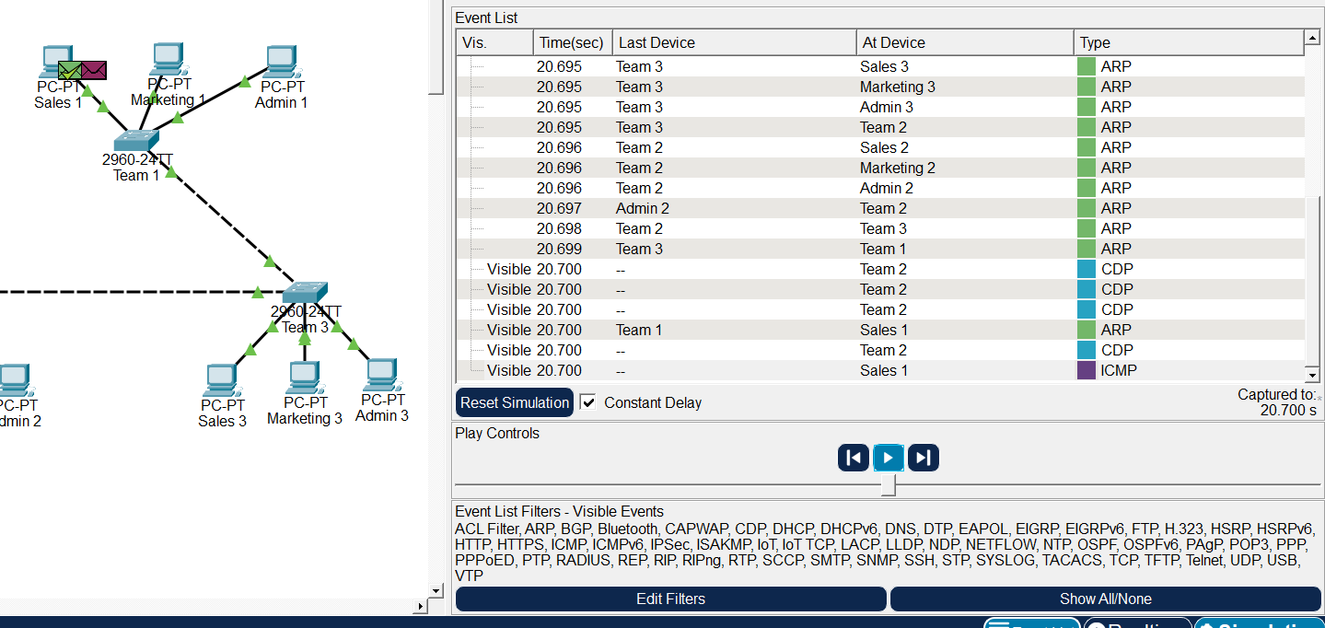 | 2
- We are going to induce a switching loop which may make Packet Tracer unstable and certainly cause some issues with the switches. Stay in Simulation mode.
- Connect a crossover cable from the gi0/1 port on Team 2 to the gi0/1 port on Team 1.

NOTE: Before doing step 7, make sure you save your switch configurations (copy run start) and save your file. Recently, Step 4 has been crashing the application. This Step hasn’t crashed the application but be prepared. If Packet Tracer crashes, reopen the .pkt file and perform Step 7 in Realtime mode.

- Return to Sales 1 try to ping Marketing 3. Uncheck the Constant Delay in the Simulation Panel and slide the speed switch to the right. Hit the play button and watch the show. While this is going on, take a snip of the panel and paste below.
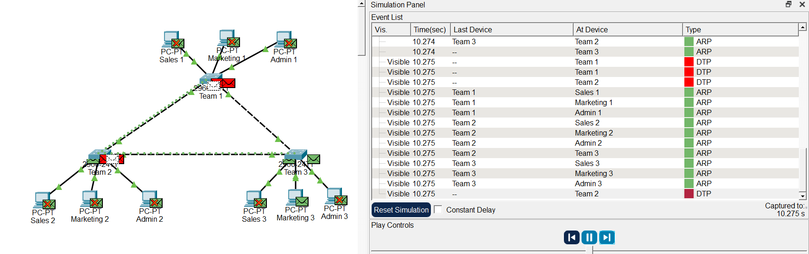e | 2
- Select the delete tool and remove the link between Team 2 and Team 1. What you have witnessed is a switching loop. You have completely corrupted the mac-address-tables on the switches, and it will take some effort to restore switch functionality. One way is to type the “clear mac-address-table” command in Privileged Exec on each switch. Another way is to return to Realtime in Packet Tracer and Ctrl-C on Sales 1 and repeat the Ping attempt until it works.
- Open each Switch and go to the configure terminal (conf t) mode. Enter “spanning-tree vlan 1”. Save the running configuration. This will reset the default mode for STP. Reconnect the cable between Team 2 and Team 1. Spanning-Tree will monitor traffic, determine a root bridge, and set the port status between switches. After convergence, Spanning-Tree will set one port in Blocking Mode and the Switching Loop situation will be prevented. Find the blocked port and run a “show span” from Privileged Exec mode on that switch. Paste the results below.
NOTE: At least on Packet Tracer, forcing a switching loop messes up the switches a lot. If, after enabling STP, no ports block, try to force a new switch to be the Root Bridge. For example, switch to Team1, enter global configuration and run “spanning-tree vlan 1 priority 4096." STP should reset and reconverge. If this does not fix the problem, consider saving the running configuration and performing a switch “reload” from Privileged Exec.

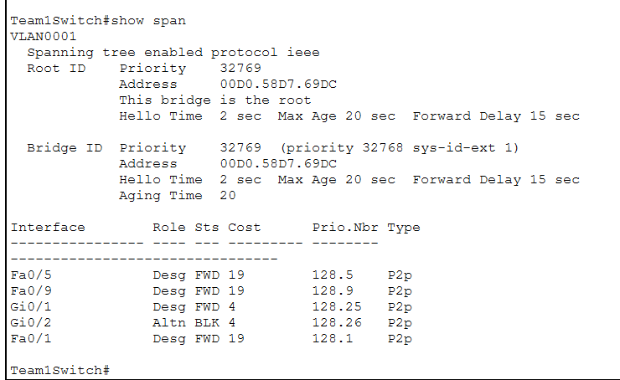 | 2
- Note the blocked port on the topology. Using the delete tool, remove a “good” link (a link with no blocked port) between the switches. After removing the link, note the status of the blocked port (it will take some time). Open Sales 1 and ping a PC on another switch. Spanning tree should open the blocked port to restore connectivity between the switches. Run the “show span” again on the switch that had the blocked port and take a snip showing the port in FWD state. This is one way to add resiliency to a switched network. Next week you will explore another way. You can restore the link you removed or leave it off.

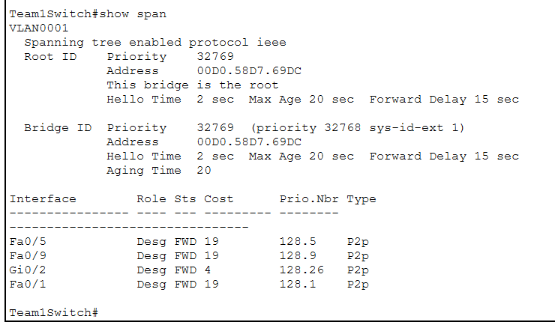 | 2
- Although Cisco switches will automatically create trunk lines, it is necessary to manually configure trunking in order for VTP to work. Configure both gi ports on each switch to be trunk lines. Search TestOut or online for the required command. By default, the trunk lines will carry all VLANs. Open the CLI on Team 3 and run the “show interfaces trunk” command. Paste the result below.

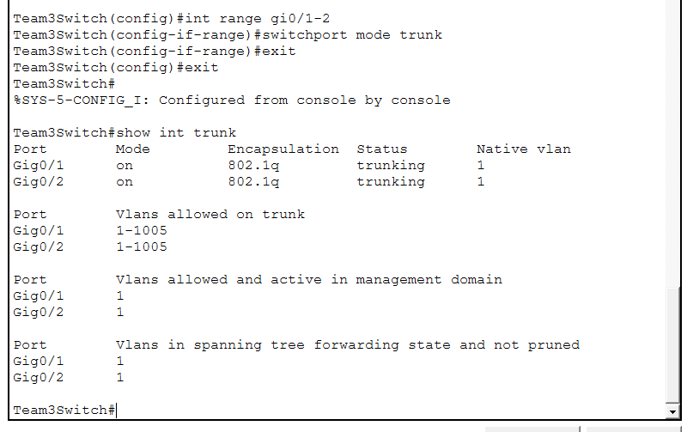 | 2
- From Team 1, create the VLANs per the instructions and configure the access ports as directed. When completed, configure the VTP password on Team 1 and the required VTP settings on the remaining switches. The VLAN information should propagate from Team 1 to the other switches. Open Team 3 and run the “show vlan” command to verify propagation. Paste results below
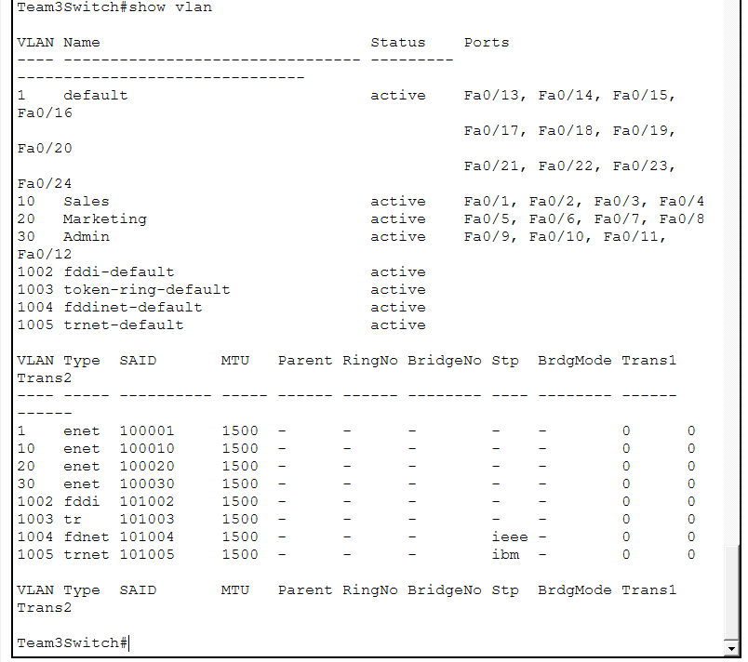 | 4
- Change the IP assignments of the PCs to match the VLAN IP assignments. You should have functioning VLANs. Open a Sales computer and ping the other Sales computers. Attempt to ping a Marketing computer. The Sales to Sales should succeed and pings to other VLANs should fail. Paste a snip of the success and failure below. Feel free to ping remaining PCs. You should only be able to ping PCs on the same VLAN.
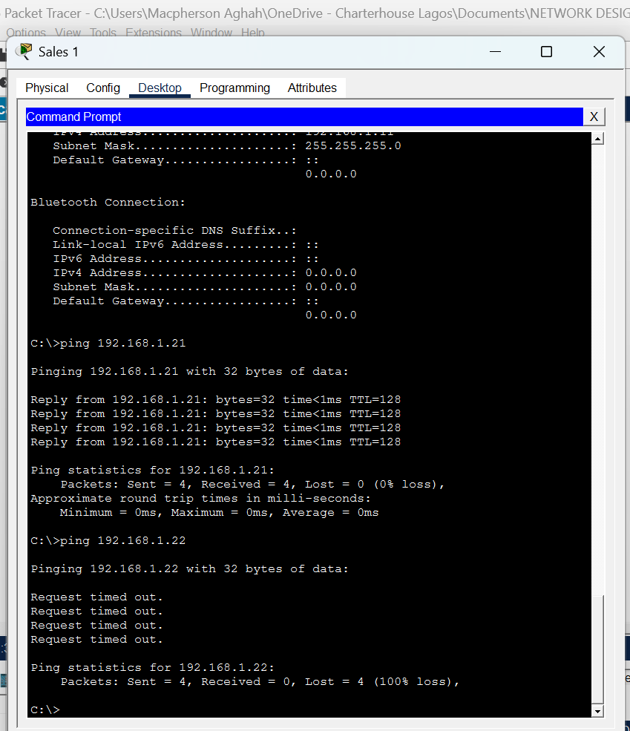sw | 4
- Run the “show interfaces trunk” command from Privileged Exec on Team 1. Notice that Vlans 1 – 1005 are allowed and 1, 10, 20, 30 are active.
- Remove VLAN 10 from Team 1 by doing the following:
- Team1# conf t
- Team1 (config) #int range gi0/1 – 2
- Team 1 (config-if-range) #switchport trunk allowed vlan remove 10
- Run the “show interfaces trunk” command from Privileged Exec. Take a snip showing that Vlan 10 is no longer allowed on the trunk lines. Paste the snip below. Attempt to ping Sales 1 from either Sales 2 or Sales 3. The ping should fail.
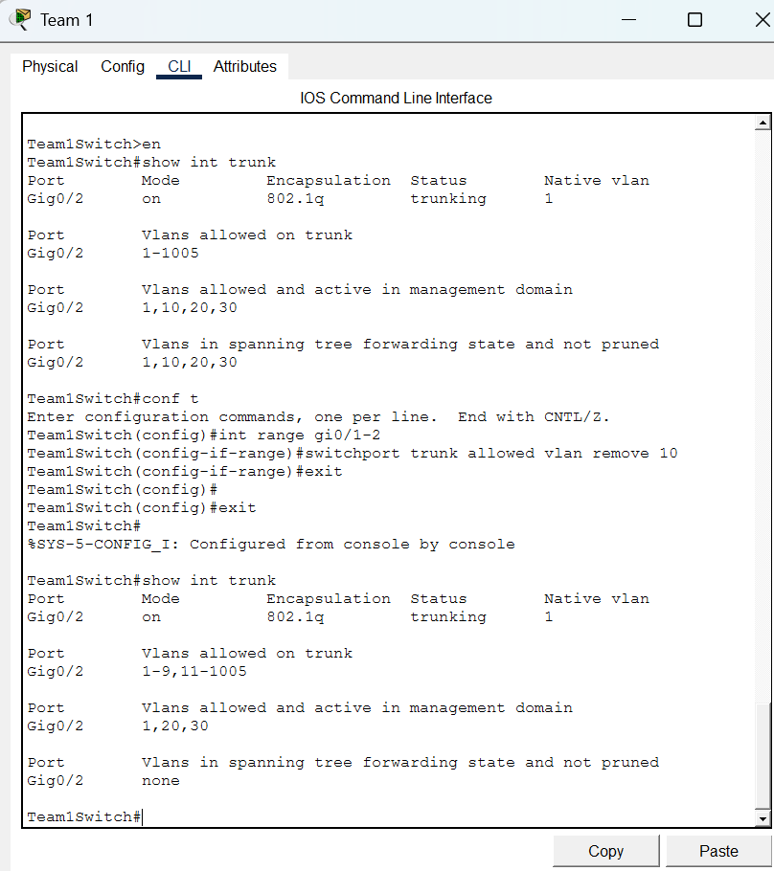  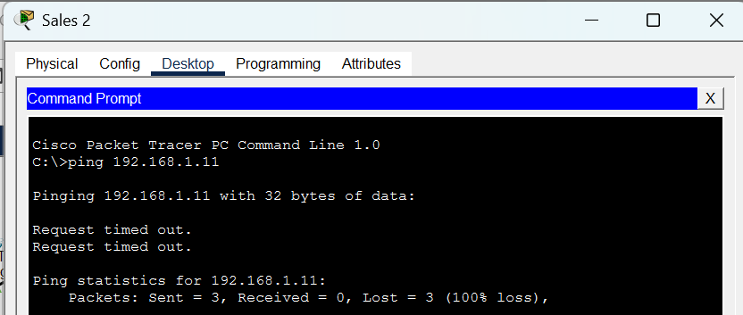 | 2
Total Points | 20

